An Industry Oriented Mini Project Report

on

Digital Watchman Using Deep Learning

Submitted in partial fulfillment of the requirements for the award of a degree of

Bachelor Of Technology

in

Computer Science And Engineering

By

    - Sairam

(21EG505828)

- Dayamani (21EG505831)

  - Likitha (21EG505870)

Under The Guidance of

Dr. P. Ravinder Rao

Asst. Professor, Department of CSE


Department of Computer Science and Engineering

ANURAG UNIVERSITY

Venkatapur (V), Ghatkesar (M), Medchal (D)., T.S-500088

(2023-2024)

i

DECLARATION

We hereby declare that the project work entitled “Digital Watchman Using Deep Learning” submitted to Anurag University in partial fulfillment of the requirements for the award of the degree of Bachelor of Technology (B. Tech) in Computer Science and Engineering is a record of an original work done by us under the guidance of Dr. P. Ravinder Rao, Assistant Professor and this project work have not been submitted to any other university for the award of any other degree or diploma.

G. Sairam

(21EG505828)

J. Dayamani

(21EG505831)

V. Likitha

(21EG505870)

Date:

ii



DEPARTMENT OF COMPUTER SCIENCE AND ENGINEERING

CERTIFICATE

This is to certify that the report entitled “Digital Watchman Using Deep Learning” being submitted by G. Sairam bearing the Hall Ticket number 21EG505828, J. Dayamani bearing the Hall Ticket number 21EG505831, V. Likitha bearing the Hall Ticket number 21EG505870 in partial fulfillment of the requirements for the award of the degree of the Bachelor of Technology in Computer Science and Engineering to Anurag University is a record of bonafide work carried out by them under my guidance and supervision.

The results embodied in this report have not been submitted to any other University for the award of any other degree.

Dr. P. Ravinder Rao Dean, CSE

Assistant Professor

External Examiner 1: External Examiner 2:

iii
ACKNOWLEDGEMENT

We would like to express our sincere thanks and deep sense of gratitude to project supervisor Dr. P. Ravinder Rao Professor, Dept of CSE for her constant encouragement and inspiring guidance without which this project could not have been completed. Her critical reviews and constructive comments improved our grasp of the subject and steered to the fruitful completion of the work. Her patience, guidance and encouragement made this project possible.

We would like to acknowledge our sincere gratitude for the support extended by Dr. G. Vishnu Murthy, Dean, Dept. of CSE, Anurag University. We also express our deep sense of gratitude to Dr. V V S S S Balaram, Academic Coordinator, Dr. Pallam Ravi, Project Coordinator and Project Review Committee members, whose research expertise and commitment to the highest standards continuously motivated us during the crucial stage of our project work.

We would like to express our special thanks to Dr. V. Vijaya Kumar, Dean School of Engineering, Anurag University, for his encouragement and timely support in our B.Tech program.

G. Sairam

(21EG505828)

J. Dayamani
(21EG505831)

V. Likitha
(21EG505870)

iv

ABSTRACT

In response to the increasing instances of fraudulent and offensive activities occurring in real-time, the need for continuous monitoring of CCTV surveillance footage becomes crucial. Human surveillance alone is not feasible due to the sheer volume of footage to be analyzed. Furthermore, it is important to quickly identify and assess frames or sections of the recordings that contain exceptional or suspicious behaviour. This project addresses these challenges by utilizing various Deep Learning models, specifically Convolutional Neural Networks (CNN) and Long-term Recurrent Convolutional Networks (LRCN), to detect signs of violence in real-time. The Deep Learning models are trained on labelled datasets containing examples of violent and nonviolent activities. By leveraging the power of CNNs, the models can extract relevant features from video frames, enabling the identification of violent behaviours. LRCNs are employed to capture temporal dependencies and analyse the sequence of frames, providing a comprehensive understanding of the activities. By implementing these Deep Learning models, the project aims to provide a rapid and automated method for identifying and flagging exceptional or suspicious activities. This technology assists security personnel in efficiently monitoring surveillance footage, enabling them to focus their attention on specific frames or sections of the recordings that require immediate assessment or intervention. Ultimately, the goal is to enhance security measures, facilitate timely response, and improve public safety in real-time surveillance environments.

Keywords: Suspicious Activity, Video Surveillance, LRCN, CNN, LSTM

v

 | CONTENTS
TITLE |  | PAGE NO
ABSTRACT |  | v
LIST OF FIGURES |  | vii
1. INTRODUCTION |  | 1
1.1. | MOTIVATION | 2
1.2. | PROBLEM DEFINITION | 2
1.3. OBJECTIVE OF THE PROJECT |  | 2
2. LITERATURE SURVEY |  | 3
3. ANALYSIS |  | 4
3.1. EXISTING SYSTEM |  | 4
3.2. PROPOSED SYSTEM |  | 4
3.3. SYSTEM REQUIREMENT SPECIFICATION |  | 5
 | 3.3.1 PURPOSE | 5
 | 3.3.2 SCOPE | 5
 | 3.3.3 OVERALL DESCRIPTION | 5
4. DESIGN |  | 6
4.1. UML DIAGRAMS |  | 8
 | 4.1.1. USE CASE | 9
4.2. ACTIVITY CHART DIAGRAM |  | 10
4.3. CLASS DIAGRAM |  | 11
5. IMPLEMENTATION |  | 12
5.1. MODULES |  | 13
5.2. MODULE DESCRIPTION |  | 13
5.3. INTRODUCTION TO TECHNOLOGIES USED |  | 14
5.4. SAMPLE CODE |  | 16
6. TEST CASES |  | 24
7. SCREENSHOTS |  | 25
8. CONCLUSION |  | 27
9. FUTURE ENHANCEMENT |  | 28
10. BIBLIOGRAPHY |  | 29

vi

LIST OF FIGURES

Figure No | Figure Name | Page No
Fig.4 | System Architecture | 7
Fig.4.1.1 | Use Case Diagram For Digital
 | Watchman Using Deep Learning | 9
Fig.4.2 | Activity Chart Diagram | 10
Fig.4.3 | Class Diagram For Digital | 11
 | Watchman Using Deep Learning

vii

1. INTRODUCTION

Security and safety is a big concern for today's modern world. In today's insecure world the video surveillance plays an important role for the security of the indoor as well as outdoor places. This hierarchical technique detects various suspicious activities such as loitering, fainting, illicit access. Then it sends an alarm message to the proper authorities. By this we can protect our society from harmful activities.

We need state of the art deep learning algorithms, fast processing, and hardware, advanced CCTV cameras in real time.

Applications: Retail stores, Banks and ATMs, Airports and Transportation Hubs, Smart Cities, Schools and Campuses, and in Parking Lots.

To overcome this challenge and improve efficiency, there is a growing need to automate the surveillance system with high accuracy. Deep learning algorithms, such as Convolutional Neural Networks (CNN) and Long Term Recurrent Neural Networks (LRCN), can play a crucial role in automating threat recognition systems.

These algorithms can be trained to identify signs of aggression and violence in real-time, effectively filtering out irregularities from normal patterns. Implementing deep learning algorithms in an automated threat recognition system can significantly reduce the reliance on human monitoring, minimizing both time and labour requirements. It enhances the overall security infrastructure and enables a more proactive approach to identifying and addressing potential threats

1

1.1 Motivation

The motivation behind suspicious activity detection using deep learning under video surveillance

Is to automate the process of identifying and reporting potentially dangerous or harmful behaviour,

without the need for constant human monitoring.

Video surveillance is a widely used security measure in many different settings, such as public places, businesses, and private homes. However, it can be difficult and time-consuming for human operators to monitor all the footage from multiple cameras simultaneously. This is where deep learning can play a role.

In addition to improving security, deep learning-based suspicious activity detection can also help to:

- Reduce the workload on human operators

- Improve the accuracy and consistency of monitoring

- Provide insights into crime patterns and trends

Overall, the motivation behind suspicious activity detection using deep learning under video surveillance is to make the world a safer place by helping to prevent and deter crime.

1.2 Problem Definition

Develop an intelligent system for detecting suspicious activity in real-time video streams to enhance security measures in public spaces, critical infrastructure, and high-risk environments.

1.3 Objective

- Deep Learning Models: The use of deep learning models, such as CNN and LSTM-RNN, indicates a sophisticated approach to anomaly detection. These models have demonstrated effectiveness in various computer vision tasks, including image and video analysis.

- Real-time Detection: By utilizing deep learning models, the system can Analyse surveillance footage in real-time, enabling immediate detection and response to offensive activities.

- Identification of Exceptional Activity: The system aims to identify specific frames and sections of the recording that contain exceptional or suspicious activity.

2
2. LITERATURE SURVEY

Video surveillance systems have gained significant attention in the field of public security. Researchers and developers have focused on various aspects of these systems, including movement recognition and object tracking, to enhance their effectiveness in monitoring and securing public spaces. I can provide you with an overview of the advancements and techniques in these areas. To recognize violent or aggressive patterns in real-time surveillance applications, the system may indeed need to perform multiple attempts. Here are a few approaches published in an article called Human Behaviour Recognition Model Based Feature and Classifier Selection [2] by GeGeo, Zhixin Li, Zhan Huan, Ying Chen, Jiuzhen Liang, Bangwen Zhou, Chenhul Dong:

- Action Recognition: Action recognition techniques can be used to identify aggressive or violent behaviour based on specific patterns of movement. Deep learning models, such as Convolutional Neural Networks (CNNs) or Recurrent Neural Networks (RNNs), can be trained on labelled video data to classify actions as aggressive or non-aggressive.

- Behaviour Modelling: The system can learn the normal behavioural patterns of individuals within a given environment. Deviations from these patterns can then be flagged as potentially aggressive or violent actions. This approach often involves training machine learning models on historical data to establish baseline behaviours.

Another article by [3] DaeHyoen Joe and Min-Suk Kim proposed about the Deep Learning Based Sequence Casual Long-Term Recurrent Convolutional Neural Network for Data Fusion Using Video Data. It the case proposed that an RNN, gradient vanishing occurs where the previously hidden state value disappears over time. To redeem a defect, an LSTM with cell state added to hidden state was devised. An LSTM can be divided into three gates: forget, input, and output, as shown in. The forget gate is determined by the previous cell state and the input gate updates to remember the current state. In addition, the output gate can find output results from both the cell state and input data. Both CNN and LSTM components can be combined into LRCN to learn spatial and temporal complex data representations, and the neural network architecture is powerful for processing sequential data.

3
- ANALYSIS

3.1 Existing System

The rise in disruptive and offensive activities has indeed increased the focus on security measures in public places. To address this issue, many locations such as shopping centres, avenues, and banks have started installing CCTVs to ensure the safety of individuals. However, manually monitoring these surveillance cameras for suspicious activities is a challenging task that requires constant attention and human resources.

To overcome this challenge and improve efficiency, there is a growing need to automate the surveillance system with high accuracy. Deep learning algorithms, such as Convolutional Neural Networks (CNN) and Recurrent Neural Networks (RNN), can play a crucial role in automating threat recognition systems.

Implementing deep learning algorithms in an automated threat recognition system can significantly reduce the reliance on human monitoring, minimizing both time and labour requirements. It enhances the overall security infrastructure and enables a more proactive approach to identifying and addressing potential threats.

3.2 Proposed System

In Real-time there has been huge amount of fraudulent and offensive activities have been taking place. As most places are under CCTV surveillance, it's quite impossible for humans to be on a constant watch over the surveillance footage. Additionally, it’s essential to show which frames and sections of the recording have the exceptional activity, which enables a more rapid assessment of unusual or suspicious behaviour. In this project, we are using different Deep Learning models (CNN and LRCN), for identifying signs of violence in real-time and performance of these Deep Learning models is also evaluated.

4
3.3 System Requirement Specification

Operating system: : Windows 10 or above/ Linux/ Max

Language: Python 3.10, Deep Learning

IDE: Google Colab

Libraries: Tensorflow, Keras, cv2, Numpy, matplotlib, twilio

3.3.1 Purpose

To build a society which is protected by a proper authority and to provide safety to the people, we are going to create a model using Deep learning algorithms, such as Convolutional Neural Networks (CNN) and long term Recurrent Neural Network (LRCN), for automating threat recognition systems. These algorithms are used to train to identify signs of aggression and violence in real-time, effectively filtering out irregularities from normal patterns.

3.3.2 Scope

The scope of this project encompasses the development and implementation of a deep learning-based system for suspicious activity detection in CCTV surveillance systems. The primary focus is on detecting fighting as suspicious activities while distinguishing walking and running as nonsuspicious activities and fighting as suspicious activities. Collecting a diverse dataset of CCTV surveillance videos that capture instances of fighting and non-suspicious activities. The dataset should encompass various environments, lighting conditions, and camera angles to ensure the model's robustness.

3.3.3 Overall Description

The project aims to develop a robust and accurate system for detecting suspicious activities in CCTV surveillance videos using deep learning techniques. By leveraging the power of neural network models, the project aims to enhance security measures in various settings such as public spaces, transportation hubs, and commercial establishments. The system will focus on categorizing fighting as suspicious activities while considering walking and running as non-suspicious activities. The goal is to enable real-time identification and early intervention in potential conflicts, thus ensuring public safety and preventing harm.

5
- DESIGN

Designing a Digital Watchman using Deep Learning specifically for detecting

suspicious activities in CCTV surveillance videos. The architecture of this project is based on

LRCN [Long-term Recurrent Convolutional Network] which is a type of deep learning model

that consists of two main components: a convolutional neural network (CNN) and long-short

term memory (LSTM). The CNN extracts spatial features from each frame of the video, while

the LSTM learns temporal relationships between the frames. Here is a concise overview of the

design process:

Data collection and preparation:
- Collect a dataset of videos and images of suspicious and non-suspicious activities.
- Annotate the dataset with labels for each activity.
- Pre-process the data to resize and normalize the images and videos.
Frame Extraction:
- Break down each video into individual frames to create a sequence of frame for each video.
- Label each frame based on the corresponding class (fight, running, walking).
LRCN Model Architecture:
- Utilize CNN for spatial feature extraction from individual frames.
- Use LSTM to capture temporal dependencies and sequential patterns across frames.
- Train the model on the labelled dataset.
Training:
- Train the model using the training set, adjusting weights to minimize the classification error.
- Validate the model using the testing set.
Suspicious Activity Detection:
- Input a new CCTV video into trained LRCN model.
- As the video progresses, the model should classify frames into the predefined classes.

By following the steps above, we can train and deploy an LRCN model to improve the security of public places, businesses, transportation hubs, and private homes and deployment.

6
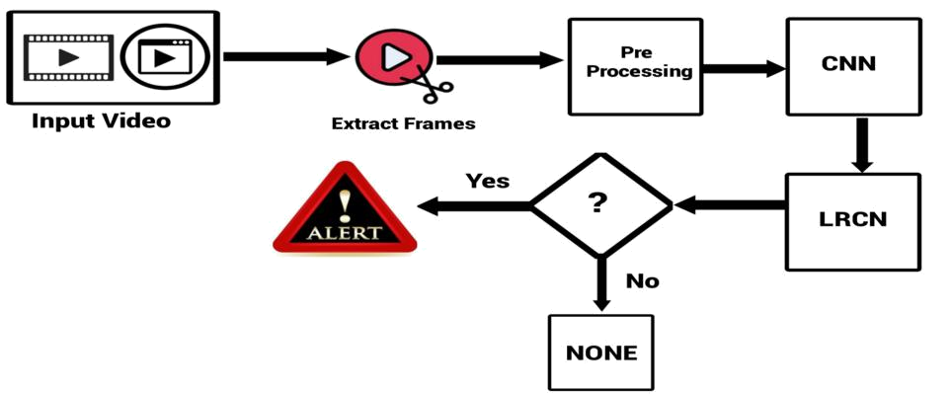

Fig 4.1.1 System Architecture

- Extract frames from the video: The first step is to extract frames from the video surveillance footage. This can be done using a standard video processing library.

- Pre-process the frames: Once the frames have been extracted, they need to be pre-processed before being passed to the CNN and LRCN. This may involve resizing the frames to a fixed size, normalizing the pixel values, and converting the frames to grayscale.

- CNN: Pass the pre-processed frames to a CNN to extract spatial features: The next step is to pass the pre-processed frames to a CNN to extract spatial features. The CNN will learn to extract features from the frames that are relevant to the task of detecting suspicious activity.

- LRCN: Pass the spatial features to an LRCN to model the temporal relationships between the frames: The spatial features extracted by the CNN are then passed to an LRCN to model the temporal relationships between the frames. The LRCN will learn to identify patterns of activity in the video that are indicative of suspicious behaviour.

- Output: The output of the LRCN is then used to predict whether or not the video contains suspicious activity. This can be done by using a simple softmax classifier.

7
- Generate an alert: If the video is predicted to contain suspicious activity, an alert can be generated. This alert can be sent to a human security officer or to an automated system for further investigation.

This process continues until all frames of the input video are processed

4.1 UML Diagrams

UML stands for Unified Modelling Language. Taking SRS document of analysis as input to the design phase drawn UML diagrams. The UML is only language so is just one part of the software development method. The UML is process independent, although optimally it should be used in a process that should be driven, architecture-centric, iterative, and incremental. The UML is language for visualizing, specifying, constructing, documenting the articles in a software- intensive system. It is based on diagrammatic representations of software components. A modelling language is a language whose vocabulary and rules focus on the conceptual and physical representation of the system. A modelling language such as the UML is thus a standard language for software blueprints. The UML is a graphical language, which consists of all interesting systems. There are also different structures that can transcend what can be represented in a programming language.

8

4.1.1 USE CASE Diagram:

Use Case diagram is used for modelling the dynamic aspect of the system. And it is a diagram that shows the set of use cases, actors and their relationship.
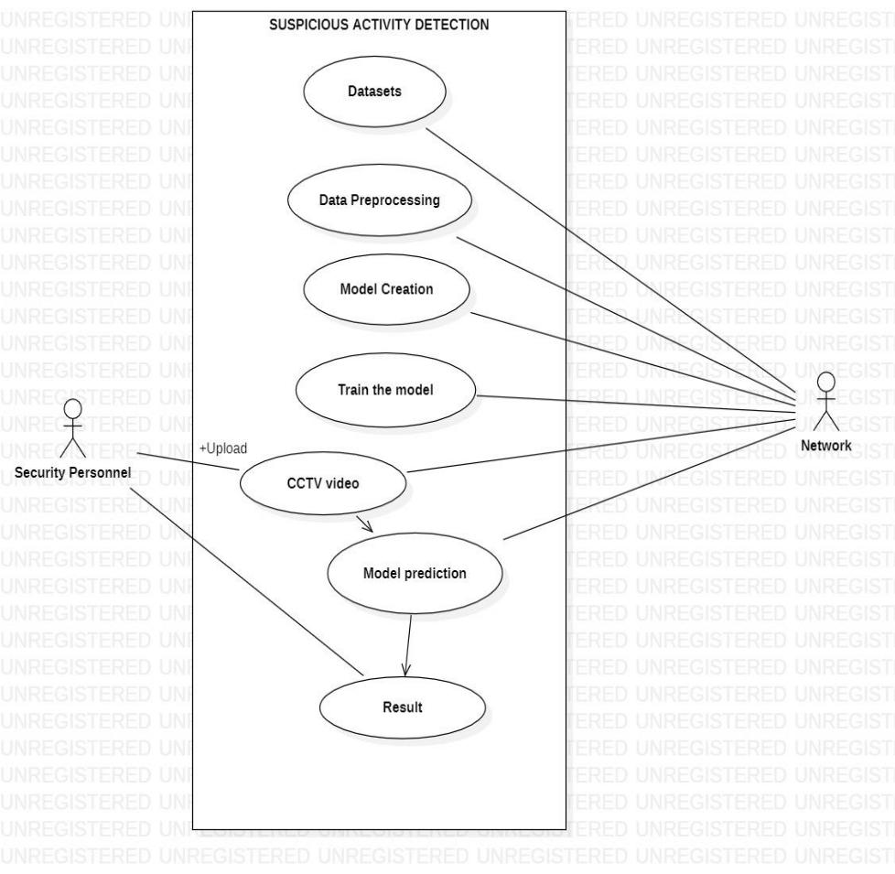

Fig 4.1.1. Use Case diagram

9
4.1.2 Activity chart Diagram:

An activity diagram visually presents a series of actions or flow of control in a system similar to a flowchart or a data flow diagram. Activity diagrams are often used in business process modelling. They can also describe the steps in a use case diagram. Activities modelled can be sequential and concurrent
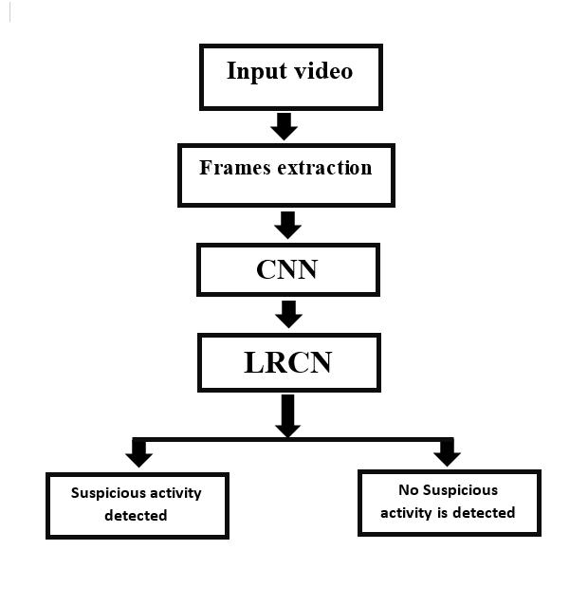

Fig 4.1.2 Activity Chart diagram

10
4.1.4 Class Diagram

A class diagram emphasizes the time ordering of messages. You form a class diagram by first placing the objects or roles that participate in the interaction at the top of your diagram, across the horizontal axis.

Typically, you place the object or role that initiates the interaction at the left, and increasingly more sub- ordinate objects or roles to the right. Next, you arrange the messages that these objects send and receive along the vertical axis in order of increasing time from top to bottom. This gives the reader a clear visual cue to the flow of control over time.
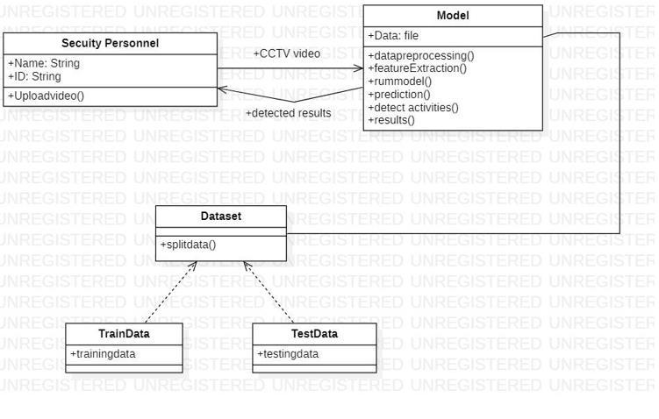

Fig 4.1.4 Class Diagram

11
5. IMPLEMENTATION

This project responds with a comprehensive strategy for continuous monitoring of CCTV surveillance footage. Recognizing the impracticality of human surveillance alone, the project employs Deep Learning models, specifically Convolutional Neural Networks (CNN) and Long-term Recurrent Convolutional Networks (LRCN). The primary objective is the rapid detection of violence, necessitating the training of models on meticulously labelled datasets encompassing examples of both violent and nonviolent activities. Leveraging the capabilities of CNNs, the models extract pertinent features from video frames, enabling the identification of violent behaviours.

The implementation begins with a accurate data collection and preparation phase, involving the assembly of a diverse dataset, annotation, and preprocessing to ensure standardized inputs. Frame extraction follows, where each video undergoes segmentation into individual frames, each labelled with the corresponding activity class such as fight, running, or walking. The LRCN model architecture, integrating CNNs for spatial feature extraction and LSTMs for temporal context, is then employed. Training involves iterative adjustments of weights to minimize classification errors, validated using a dedicated testing set.

The data collection and preparation phase involves gathering data from a variety of sources, cleaning (removing errors) and transforming it into an avi format that can be used for analysis, and ensuring that it is of high quality. Then labels or tags are assigned to each piece of data in the dataset. For surveillance applications, this involves labelling frames or sequences with information about the activities they represent such as fight, running, and walking.

Then preprocessing is done to transform the raw data into a format that is suitable for analysis and modelling. This can involve a variety of tasks, such as resizing i.e adjusting the dimensions of the images and videos to a standardized format, normalization.

Then CNN extracts spatial features within individual frames filters and learns the model and LRCN captures the temporal dependencies across frames.

Finally the technology is applied in real-time suspicious activity detection. A new CCTV video is input into the trained LRCN model, which progressively classifies frames into predefined categories as the video unfolds. The overarching aim is the deployment of an efficient and automated system that enhances security measures, enables prompt intervention, and ultimately improves public safety in real-time surveillance environments across various settings including public places, educational Institutions, ect.

12

5.1 Modules

- Data Collection and Input Module.

- Data Preprocessing and Model Creation Module

- Data Analysis and Detecting Module

5.2 Module Description

- Data Collection and Input Module:

This module encompasses the processes involved in gathering and preparing the data that the model will be trained on. The effectiveness of the data collection and input module significantly impacts the model's performance, as a well-curated and appropriately pre-processed dataset is essential for training a robust model.

- Data Preprocessing and Model Creation Module:

The data is preprocessed by resizing images or videos to a consistent resolution, normalizing pixel values. The model is created by relu and sigmoid activation functions and then the model is trained using train dataset.

3. Data Analysis and Detecting Module

This module involves the utilization of deep learning models, such as Convolutional Neural Networks (CNNs) and Long-term Recurrent Convolutional Networks (LRCNs), to analyze the processed data and detect suspicious or exceptional activities.

13

a. Introduction to Technologies used:

Google Colab

You will quickly learn and use Google Colab if you know and have used Jupyter notebook before. Colab is basically a free Jupyter notebook environment running wholly in the cloud. Most importantly, Colab does not require a setup, plus the notebooks that you will create can be simultaneously edited by your team members – in a similar manner you edit documents in Google Docs. The greatest advantage is that Colab supports most popular machine learning libraries which can be easily loaded in your notebook.

As a developer, you can perform the following using Google Colab;

- Write and execute code in Python

- Create/Upload/Share notebooks

- Import/Save notebooks from/to Google Drive

- Import/Publish notebooks from GitHub

- Import external datasets

- Integrate PyTorch, TensorFlow, Keras, OpenCV

- Free Cloud service with free GPU

Some reasons why you want to opt to use Colab over plain Jupyter Notebook include;

- Pre-installed Libraries

- Saved on the Cloud

- Collaboration

- Free GPU and TPU Use

Let us now look at each of these reasons.

The other great feature that Google Colab offers is the collaboration feature. If you are working with multiple developers on a project, it is great to use Google Colab notebook. Just like collaborating on a Google Docs document, you can co-code with multiple developers using a Google Colab notebook. Besides, you can also share your completed work with other developers.

14

Tensorflow & Keras: TensorFlow and Keras can be used to develop a suspicious activity detection system which uses a convolutional neural network (CNN) to extract features from images or videos, and then use those features to train a model and LRCN classifies whether the frame has any suspicious activity or not.

cv2: OpenCV can be used to extract the frames from video to extract features from images or videos, and then use those features to train a model to classify the images or videos as suspicious or not suspicious.

numpy: NumPy is a fundamental library for numerical operations in Python. It's commonly used for array and matrix manipulation. In this code, it's used for various mathematical calculations and creating arrays.

matplotlib: Matplotlib is a popular library in Python for creating static, interactive visualizations and plots.

Twilio: Twilio is a cloud communications platform that enables developers to build, scale, and operate real-time communication applications. Twilio provides a wide range of APIs and services such as SMS, what’s app security personnel to notify them of suspicious activity.

Moviepy: MoviePy is a Python library for video editing, which can be used for basic operations (like cuts, concatenations, title insertions). In this project it is used to extract frames from a video, create a video of the suspicious activity that has been detected.

15

Sample Code:

import os
import cv2
import pafy
import math
import random

import numpy as np
import datetime as dt
import tensorflow as tf
from collections import deque
import matplotlib.pyplot as plt

from moviepy.editor import *

#%matplotlib inline

from sklearn.model_selection import train_test_split

from tensorflow.keras.layers import *

from tensorflow.keras.models import Sequential from tensorflow.keras.utils import to_categorical from tensorflow.keras.callbacks import EarlyStopping from tensorflow.keras.utils import plot_model

seed_constant = 5
np.random.seed(seed_constant)

random.seed(seed_constant)
tf.random.set_seed(seed_constant)

I

!pip install pafy youtube-dl moviepy

seed_constant = 5

np.random.seed(seed_constant)
random.seed(seed_constant)
tf.random.set_seed(seed_constant)

plt.figure(figsize = (20, 20))

all_classes_names = os.listdir('Dataset')

for counter, random_index in enumerate(range(len(all_classes_names)), 1):

selected_class_Name = all_classes_names[random_index]

video_files_names_list = os.listdir(f'Dataset/{selected_class_Name}')

selected_video_file_name = random.choice(video_files_names_list)

16

video_reader =

cv2.VideoCapture(f'Dataset/{selected_class_Name}/{selected_video_file_name}')
video_reader.set(1, 25)

_, bgr_frame = video_reader.read()

bgr_frame = cv2.resize(bgr_frame ,(224,224))

video_reader.release()

rgb_frame = cv2.cvtColor(bgr_frame, cv2.COLOR_BGR2RGB)

cv2.putText(rgb_frame, selected_class_Name, (10, 30), cv2.FONT_HERSHEY_SIMPLEX, 0.8, (0, 200, 255), 2)

plt.subplot(5, 4, counter);plt.imshow(rgb_frame);plt.axis('off')

IMAGE_HEIGHT , IMAGE_WIDTH = 64, 64

SEQUENCE_LENGTH = 30

DATASET_DIR = "Dataset"

CLASSES_LIST = ["walking", "fights", "running"]

ef frames_extraction(video_path):

frames_list = []

video_reader = cv2.VideoCapture(video_path)

video_frames_count = int(video_reader.get(cv2.CAP_PROP_FRAME_COUNT)) skip_frames_window = max(int(video_frames_count/SEQUENCE_LENGTH), 1) for frame_counter in range(SEQUENCE_LENGTH):

video_reader.set(cv2.CAP_PROP_POS_FRAMES, frame_counter * skip_frames_window)

success, frame = video_reader.read()

if not success:

break

resized_frame = cv2.resize(frame, (IMAGE_HEIGHT, IMAGE_WIDTH)) normalized_frame = resized_frame / 255 frames_list.append(normalized_frame)

video_reader.release()

return frames_list

17

def create_dataset():

features = []

labels = []

video_files_paths = []

for class_index, class_name in enumerate(CLASSES_LIST):

print(f'Extracting Data of Class: {class_name}')

files_list = os.listdir(os.path.join(DATASET_DIR, class_name))

for file_name in files_list:

video_file_path = os.path.join(DATASET_DIR, class_name, file_name)

frames = frames_extraction(video_file_path)

if len(frames) == SEQUENCE_LENGTH:

features.append(frames)

labels.append(class_index)

video_files_paths.append(video_file_path)

features = np.asarray(features)

labels = np.array(labels)

return features, labels, video_files_paths

features, labels, video_files_paths = create_dataset()

print(features.shape, labels.shape)

one_hot_encoded_labels = to_categorical(labels)

features_train, features_test, labels_train, labels_test =

train_test_split(features, one_hot_encoded_labels, test_size = 0.25, shuffle =
True, random_state = seed_constant)
features = None

labels = None

ef create_LRCN_model():

model = Sequential()

18

model.add(TimeDistributed(Conv2D(32, (3, 3), padding='same',activation = 'relu'), input_shape = (SEQUENCE_LENGTH, IMAGE_HEIGHT, IMAGE_WIDTH, 3)))

model.add(TimeDistributed(MaxPooling2D((4, 4))))

model.add(TimeDistributed(Conv2D(64, (3, 3), padding='same',activation = 'relu')))

model.add(TimeDistributed(MaxPooling2D((4, 4))))

model.add(TimeDistributed(Conv2D(128, (3, 3), padding='same',activation = 'relu')))

model.add(TimeDistributed(MaxPooling2D((2, 2))))

model.add(TimeDistributed(Conv2D(256, (2, 2), padding='same',activation = 'relu')))

model.add(TimeDistributed(MaxPooling2D((2, 2))))

model.add(TimeDistributed(Flatten()))

model.add(LSTM(32))

model.add(Dense(len(CLASSES_LIST), activation = 'softmax'))

model.summary()

return model

model = create_LRCN_model()

early_stopping_callback = EarlyStopping(monitor = 'accuracy', patience = 10, mode = 'max', restore_best_weights = True)

model.compile(loss = 'categorical_crossentropy', optimizer = 'Adam', metrics = ["accuracy"])

model_training_history = model.fit(x = features_train, y = labels_train, epochs = 70, batch_size = 4 , shuffle = True, vali

model.save("Suspicious_Human_Activity_Detection_LRCN_Model.h5")

def plot_metric(model_training_history, metric_name_1, metric_name_2, plot_name):

metric_value_1 = model_training_history.history[metric_name_1] metric_value_2 = model_training_history.history[metric_name_2]

epochs = range(len(metric_value_1))

plt.plot(epochs, metric_value_1, 'blue', label = metric_name_1)

plt.plot(epochs, metric_value_2, 'red', label = metric_name_2)

plt.title(str(plot_name))

19

plt.legend()

I

plot_metric(model_training_history, 'loss', 'val_loss', 'Total Loss vs Total Validation Loss')

plot_metric(model_training_history, 'accuracy', 'val_accuracy', 'Total Accuracy vs Total Validation Accuracy')

acc = 0

for i in range(len(features_test)):

predicted_label = np.argmax(model.predict(np.expand_dims(features_test[i],axis =0))[0])

actual_label = np.argmax(labels_test[i])
if predicted_label == actual_label:
acc += 1

acc = (acc * 100)/len(labels_test)
print("Accuracy =",acc)

PREDECTIONS

from tensorflow.keras.models import load_model import cv2

import numpy as np
import pandas as pd
from collections import deque
from moviepy.editor import *

- Specify the height and width to which each video frame will be resized in our dataset.

IMAGE_HEIGHT , IMAGE_WIDTH = 64, 64

- Specify the number of frames of a video that will be fed to the model as one sequence.

SEQUENCE_LENGTH = 30

- Specify the directory containing the UCF50 dataset.
DATASET_DIR = "Dataset"

- Specify the list containing the names of the classes used for training. Feel free to choose any set of classes.

CLASSES_LIST = ["walking", "fight", "running"]

model = load_model("Suspicious_Human_Activity_Detection_LRCN_Model.h5")

def predict_single_action(video_file_path, SEQUENCE_LENGTH):

'''

This function will perform single action recognition prediction on a video using the LRCN model.

Args:

video_file_path: The path of the video stored in the disk on which the action recognition is to be performed.

SEQUENCE_LENGTH: The fixed number of frames of a video that can be passed to the model as one sequence.

'''

20

- Initialize the VideoCapture object to read from the video file. video_reader = cv2.VideoCapture(video_file_path)

- Get the width and height of the video.

original_video_width = int(video_reader.get(cv2.CAP_PROP_FRAME_WIDTH))

original_video_height = int(video_reader.get(cv2.CAP_PROP_FRAME_HEIGHT))

- Declare a list to store video frames we will extract. frames_list = []

- Initialize a variable to store the predicted action being performed in the

video. predicted_class_name = ''

- Get the number of frames in the video.

video_frames_count = int(video_reader.get(cv2.CAP_PROP_FRAME_COUNT))

- Calculate the interval after which frames will be added to the list. skip_frames_window = max(int(video_frames_count/SEQUENCE_LENGTH),1)

- Iterating the number of times equal to the fixed length of sequence. for frame_counter in range(SEQUENCE_LENGTH):

# Set the current frame position of the video.

video_reader.set(cv2.CAP_PROP_POS_FRAMES, frame_counter * skip_frames_window)

# Read a frame.

success, frame = video_reader.read()

- Check if frame is not read properly then break the loop. if not success:

break

- Resize the Frame to fixed Dimensions.

resized_frame = cv2.resize(frame, (IMAGE_HEIGHT, IMAGE_WIDTH))

- Normalize the resized frame by dividing it with 255 so that each pixel value then lies between 0 and 1.
normalized_frame = resized_frame / 255

- Appending the pre-processed frame into the frames list

frames_list.append(normalized_frame)

- Passing the pre-processed frames to the model and get the predicted probabilities.

predicted_labels_probabilities = model.predict(np.expand_dims(frames_list, axis = 0))[0]

- Get the index of class with highest probability.

predicted_label = np.argmax(predicted_labels_probabilities)

- Get the class name using the retrieved index. predicted_class_name = CLASSES_LIST[predicted_label]

- Display the predicted action along with the prediction confidence. print(f'Action Detected: {predicted_class_name}\nConfidence:

{predicted_labels_probabilities[predicted_label]}')

21

- Release the VideoCapture object. video_reader.release()

predict_single_action("/Predict_walking.avi",SEQUENCE_LENGTH)

predict_single_action("/content/Predict_running.avi",SEQUENCE_LENGTH)

def predict_on_video(video_file_path, output_file_path, SEQUENCE_LENGTH):
'''

This function will perform action recognition on a video using the LRCN model.

Args:

video_file_path: The path of the video stored in the disk on which the action recognition is to be performed.

output_file_path: The path where the ouput video with the predicted action being performed overlayed will be stored.

SEQUENCE_LENGTH: The fixed number of frames of a video that can be passed to the model as one sequence.

'''

- Initialize the VideoCapture object to read from the video file. video_reader = cv2.VideoCapture(video_file_path)

- Get the width and height of the video.

original_video_width = int(video_reader.get(cv2.CAP_PROP_FRAME_WIDTH))

original_video_height = int(video_reader.get(cv2.CAP_PROP_FRAME_HEIGHT))

- Initialize the VideoWriter Object to store the output video in the disk. video_writer = cv2.VideoWriter(output_file_path,

cv2.VideoWriter_fourcc(*'DIVX'),
video_reader.get(cv2.CAP_PROP_FPS),

(original_video_width, original_video_height))

- Declare a queue to store video frames. frames_queue = deque(maxlen = SEQUENCE_LENGTH)

- Initialize a variable to store the predicted action being performed in the

video. predicted_class_name = ''

- Iterate until the video is accessed successfully.

while video_reader.isOpened():

# Read the frame.

ok, frame = video_reader.read()

- Check if frame is not read properly then break the loop. if not ok:
break

- Resize the Frame to fixed Dimensions.

resized_frame = cv2.resize(frame, (IMAGE_HEIGHT, IMAGE_WIDTH))

- Normalize the resized frame by dividing it with 255 so that each pixel value then lies between 0 and 1.

normalized_frame = resized_frame / 255

- Appending the pre-processed frame into the frames list.

22

frames_queue.append(normalized_frame)

- Check if the number of frames in the queue are equal to the fixed sequence length.

if len(frames_queue) == SEQUENCE_LENGTH:

  - Pass the normalized frames to the model and get the predicted

probabilities. predicted_labels_probabilities =

model.predict(np.expand_dims(frames_queue, axis = 0))[0]

  - Get the index of class with highest probability.

predicted_label = np.argmax(predicted_labels_probabilities)

  - Get the class name using the retrieved index. predicted_class_name = CLASSES_LIST[predicted_label]

- Write predicted class name on top of the frame. cv2.putText(frame, predicted_class_name, (10, 30),

cv2.FONT_HERSHEY_SIMPLEX, 1, (0, 255, 0), 2)

  - Write The frame into the disk using the VideoWriter Object. video_writer.write(frame)

- Release the VideoCapture and VideoWriter objects.

video_reader.release()

video_writer.release()

%%time

predict_on_video("/Predict_Human-Activity.avi","Human-Activity-Prediction.avi",SEQUENCE_LENGTH)

VideoFileClip("Human-Activity-Prediction.avi", audio=False).ipython_display()

23
1. TEST CASES

Test |  | Input | Expected Output |  | Actual Output
case ID |  |  |  |  |  | Rate
1. | Test the |  | The model should |  | The model | Success
 | model’s ability |  | correctly classify |  | correctly classified
 | to avoid |  | these non- |  | the non-suspicious
 | misclassifying |  | suspicious |  | activities
 | non- suspicious |  | activities as non-
 | activities as |  | suspicious
 | suspicious
2. | Test the |  | The model should |  | The model detected | Success
 | model’s |  | detect suspicious |  | suspicious activities
 | performance |  | activities,
 | and real-time |  | ensuring timely
 | capabilities by |  | intervention and
 | processing a |  | prevention of
 | stream of |  | potential conflicts
 | CCTV
 | surveillance
 | Video footage
3. | Test the |  | The model should |  | The model detected | Success
 | model’s |  | remain effective |  | suspicious and non-
 | resilience to |  | in detecting and |  | suspicious activities
 | environmental |  | classifying |  | despite of
 | changes, such |  | suspicious and |  | environmental
 | dynamic |  | non-suspicious |  | changes
 | backgrounds or |  | activities despite
 | moving objects |  | environmental
 |  |  | changes and
 |  |  | potential
 |  |  | distractions
4. | The | model’s | The model should |  | The model detected | Success
 | performance in |  | be able to detect |  | suspicious activities
 | low | lighting | and classify |  | accurately in low
 | conditions |  | suspicious |  | lighting
 | where visibility |  | activities
 | may be limited |  | accurately, even
 |  |  | when in low
 |  |  | lighting
 |  |  |  | 24

- SCREENSHOTS
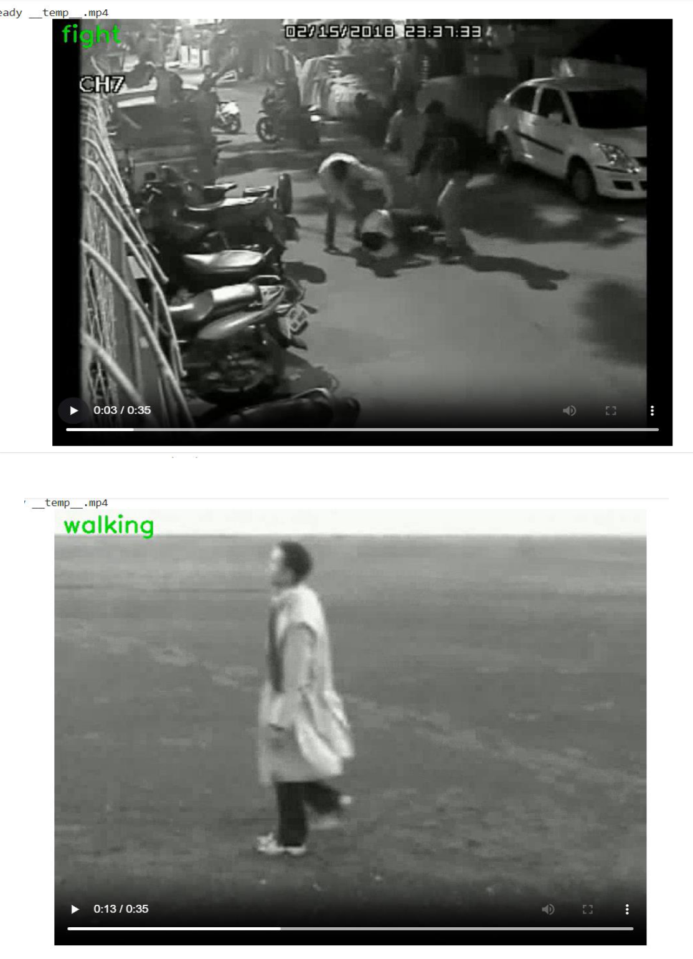

25

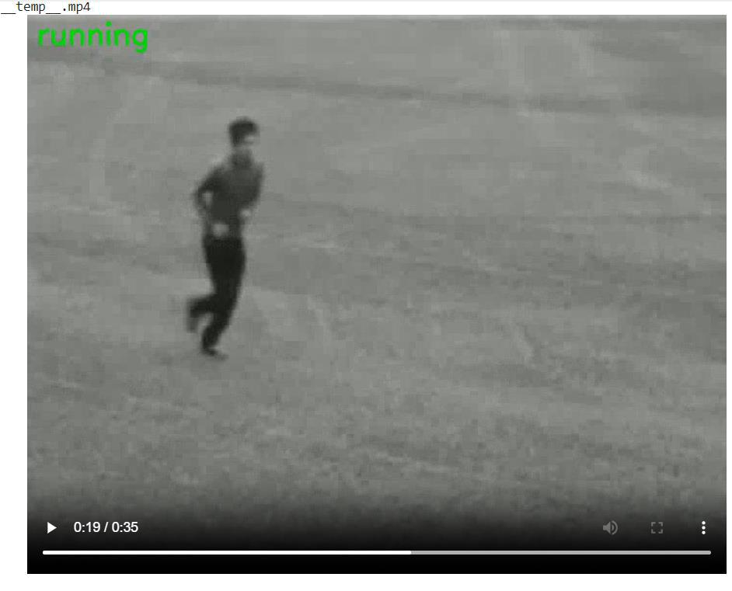

26

3. CONCLUSION

The work suggests the implementation of a deep learning neural network model for suspicious activity detection in CCTV surveillance videos has shown promising results. By categorizing fighting's as suspicious activities and considering walking and running as non-suspicious activities, the model can effectively identify potentially dangerous situations and aid in maintaining public safety. However, it's important that the project's success depends on the quality and variety of the training datasets. To improve accuracy, the neural network model needs to be trained on a diverse range of fighting's and non-suspicious activities, ensuring it can effectively distinguish between them and minimize false alarms. Hence, the overall accuracy of the model is 86.66%

27
4. FUTURE ENHANCEMENTS

The result of the detection obtained by the model encompasses several potential advancements and provide the scope for the future work the functionalities of this project can be scaled up in the future:

- Enhancing the model by refining the training datasets we can improve the accuracy. This

could involve increasing the diversity of activities captured in the datasets, considering different environmental conditions.

- Currently, the model has been trained on fighting, running and walking activities. As

Considering fighting’s under suspicious activity, it can be further broadened by taking variety of violence anomalies such as Shooting, Road Accidents, Robbery, Burglar etc.

28
  - BIBLIOGRAPHY

- Amrutha C.V, C. Jyotsna, Amudha J. “Deep Learning Approach for Suspicious Activity

Detection from Surveillance Video” Dept. of Computer Science & Engineering, Amrita School of Engineering, Bengaluru, Amrita Vishwa Vidyapeetham, India.

- Ms.U.M.Kamthe, Dr. C.G.Patil “ Suspicious Activity Recognition in Video Surveillance System” Dept. of E & TC SAE, Pune, India.

- Virender Singha, Swati Singha, Dr. Pooja Gupta. Real-Time Anomaly Recognition Through CCTV Using Neural Networks 1877-0509 © 2020 The Authors. Published by Elsevier B.V

- Human Behaviour Recognition Model Based Feature and Classifier Selection by GeGeo, Zhixin Li, Zhan Huan, Ying Chen, Jiuzhen Liang, Bangwen Zhou, Chenhul Dong. Published:

- November 2021Sensors 2021, 21(23), 7791; https://doi.org/10.3390/s21237791

  - DaeHyoen Joe and Min-Suk Kim proposed about the Deep Learning Based Sequence Casual Long-Term Recurrent Convolutional Neural Network for Data Fusion Using Video

Data. Published: 24 February 2023 Electronics 2023, 12(5),1115; https://doi.org/10.3390/electronics12051115

29

